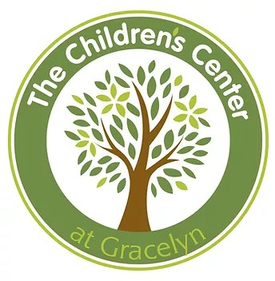
Children’s Center at Gracelyn
Board Member Application

GENERAL INFORMATION (feel free to include a resume)

Full Name:

Address:

Telephone (cell, home, work):

Best time to call:

Email:

Are you a parent of a child who is currently enrolled in the Children’s Center at Gracelyn?

Are you a current member of Grace Covenant Presbyterian Church?

EMPLOYMENT & VOLUNTEER EXPERIENCES

Please list employment and volunteer experiences you will bring to the Board

BOARDS & COMMITTEES

Please describe your experience on any boards or committees on which you currently serve or have served (business, civic, political, faith-based, social, etc).

YOUR INTERESTS, SKILLS, TRAINING, LIFE EXPERIENCES, COMMUNITY CONNECTIONS

What motivates you to consider joining the Board of the Children’s Center at Gracelyn?

Please check the interests you have and the skills and experiences that apply to you.

Interest Skills Experience
______ ______ ______ Personnel/Human Resources
______ ______ ______ Budget
______ ______ ______ Administration/Management
______ ______ ______ Early Childhood Education
______ ______ ______ Nonprofit Board Experience
______ ______ ______ Community Service
______ ______ ______ Fundraising/Grant Writing
______ ______ ______ Outreach/Advocacy
______ ______ ______ Cultural Transformation/Org.Development
______ ______ ______ Technology/Social Media
______ ______ ______ Facilities/Landscape
______ ______ ______ Strategic Planning
______ ______ ______ Adult Learning & Group Facilitation
______ ______ ______ Other

In addition to the above, what life experiences, training and talent will you bring to the Board?

What Community Connections will you bring to the Board? (please check all that apply)

_____ Corporate
_____ Education
_____ Faith-based organizations
_____ Health Care
_____ Mental Health
_____ Media
_____ Philanthropy
_____ Political
_____ Small Business
_____ Social Services
_____ Other

YOUR COMMITMENT

Will your schedule and other commitments allow you to actively participate on the Board and its Committees?

Thank you for considering a position on our Board!

Please sign and return this application by May 16th to:

Jeannie Aiken, Director
789A Merrimon Ave
Asheville, NC 28804

Or fax to: 828-253-0546

Or scan and email to: childrenscentero@bellsouth.net

Applicant Signature:_______________________________________________(date)

